### **Project 01**

### **Deploying a Node.js App Using Minikube Kubernetes**

#### **Overview**

This project guides you through deploying a Node.js application using Minikube Kubernetes. You'll use Git for version control, explore branching and fast-forward merges, and set up Kubernetes services and deployment pods, including ClusterIP and NodePort service types.

#### **Prerequisites**

* Minikube installed
* kubectl installed
* Git installed
* Node.js installed ([https://nodejs.org/en/download/package-manager/all#debian-and-ubuntu-based-linux-distributions](https://nodejs.org/en/download/package-manager/all" \l "debian-and-ubuntu-based-linux-distributions))

#### **Project Steps**

### **1. Set Up Git Version Control**

**1.1. Initialize a Git Repository**

Create a new directory for your project:  
  
mkdir nodejs-k8s-project

cd nodejs-k8s-project

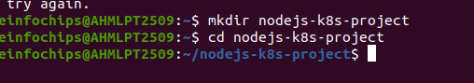

Initialize a Git repository:  
  
git init

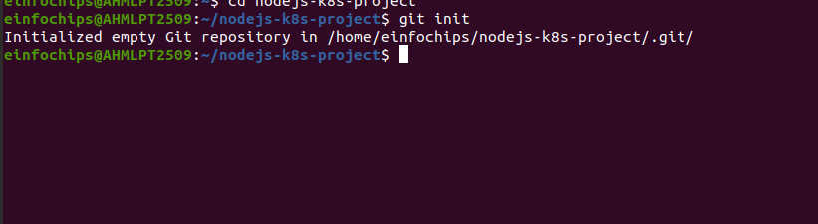

**1.2. Create a Node.js Application**

Initialize a Node.js project:  
  
npm init –y

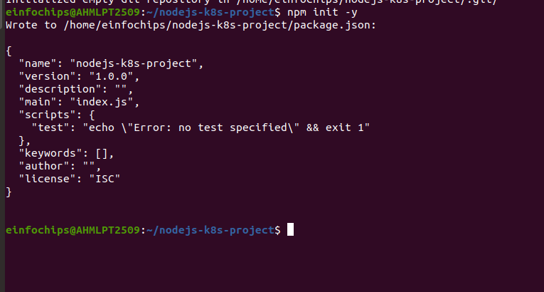

Install Express.js:  
  
npm install express

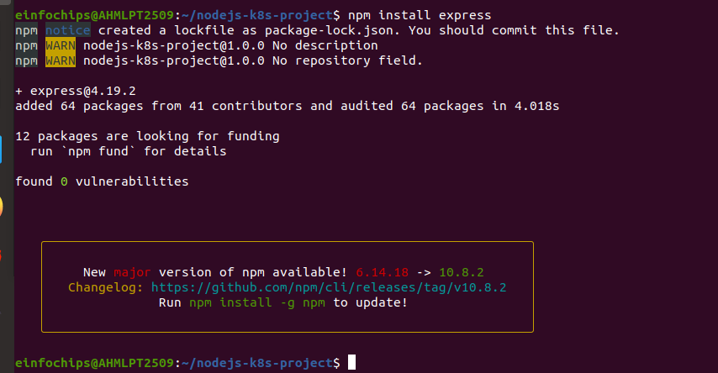

Create an index.js file with the following content:

const express = require('express');

const app = express();

const port = 3000;

app.get('/', (req, res) => {

res.send('Hello, Kubernetes!');

});

app.listen(port, () => {

console.log(`App running at http://localhost:${port}`);

});

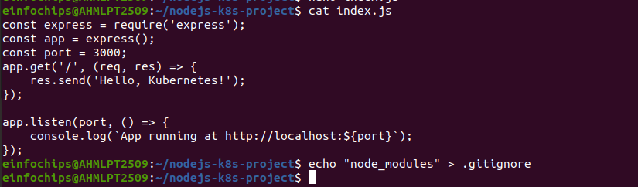

Create a .gitignore file to ignore node_modules:  
  
node_modules



**1.3. Commit the Initial Code**

Add files to Git:  
  
git add .

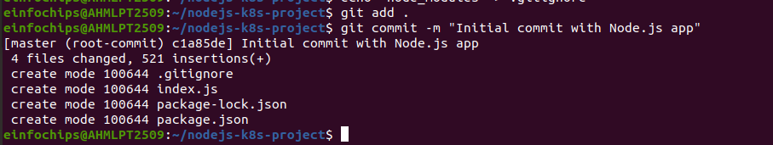

Commit the changes:  
  
git commit -m "Initial commit with Node.js app"



### **2. Branching and Fast-Forward Merge**

**2.1. Create a New Branch**

Create and switch to a new branch feature/add-route:  
  
git checkout -b feature/add-route



**2.2. Implement a New Route**

Modify index.js to add a new route:  
  
app.get('/newroute', (req, res) => {

res.send('This is a new route!');

});

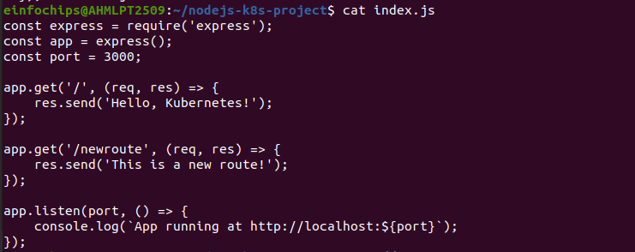

Commit the changes:  
  
git add .

git commit -m "Add new route"

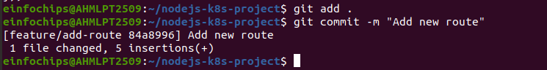

**2.3. Merge the Branch Using Fast-Forward**

Switch back to the main branch:  
  
git checkout main

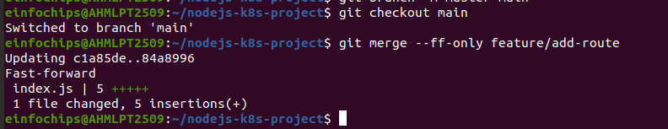

Merge the feature/add-route branch using fast-forward:  
  
git merge --ff-only feature/add-route



Delete the feature branch:  
  
git branch -d feature/add-route



### **3. Containerize the Node.js Application**

**3.1. Create a Dockerfile**

Create a Dockerfile with the following content:  
  
FROM node:14

WORKDIR /app

COPY package*.json ./

RUN npm install

COPY . .

EXPOSE 3000

CMD ["node", "index.js"]

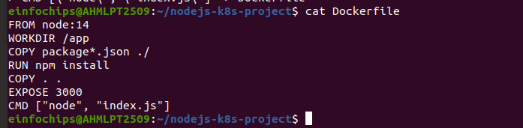

**3.2. Build and Test the Docker Image**

Build the Docker image:  
  
docker build -t nodejs-k8s-app .

docker build -t nodejs-k8s-app .

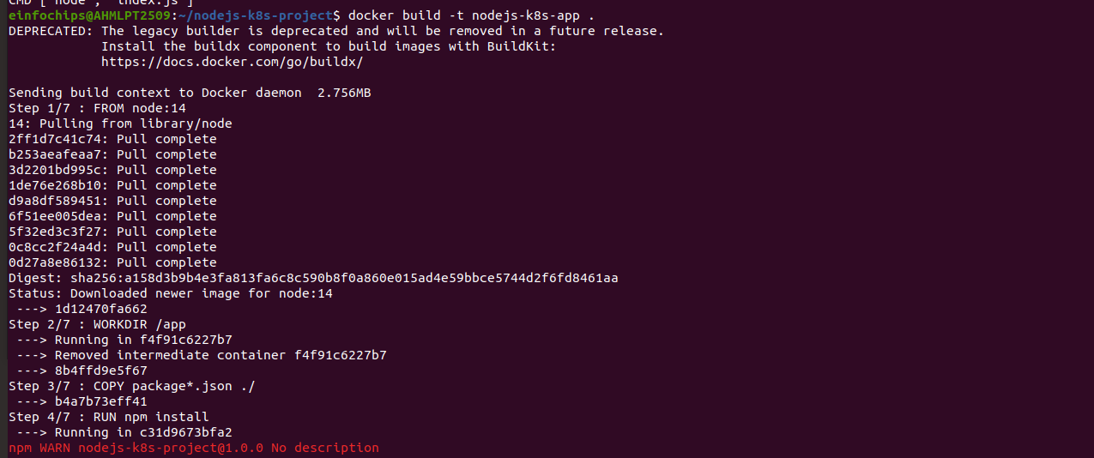

Run the Docker container to test:  
  
docker run -p 3000:3000 nodejs-k8s-app



1. Access [http://localhost:3000](http://localhost:3000/) to see the app running.

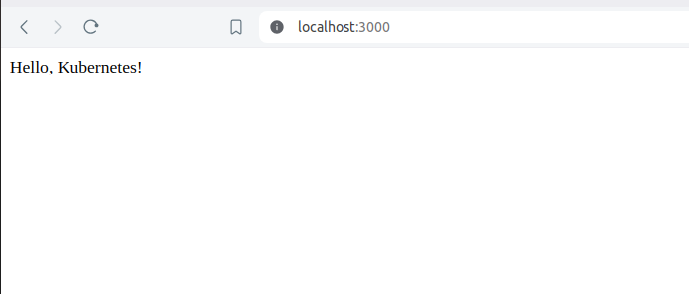

### **4. Deploying to Minikube Kubernetes**

**4.1. Start Minikube**

Start Minikube:

minikube start

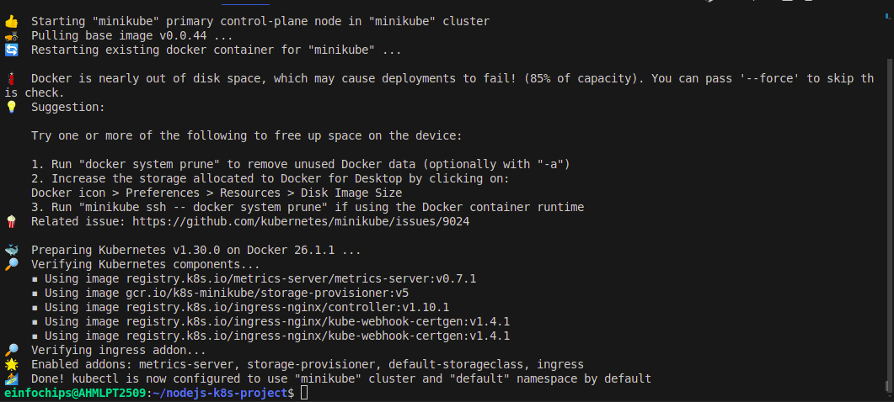

**4.2. Create Kubernetes Deployment and Service Manifests**

Create a deployment.yaml file:  
  
apiVersion: apps/v1

kind: Deployment

metadata:

name: nodejs-app

spec:

replicas: 2

selector:

matchLabels:

app: nodejs-app

template:

metadata:

labels:

app: nodejs-app

spec:

containers:

- name: nodejs-app

image: nodejs-k8s-app:latest

ports:

- containerPort: 3000

Create a service.yaml file for ClusterIP:  
  
apiVersion: v1

kind: Service

metadata:

name: nodejs-service

spec:

selector:

app: nodejs-app

ports:

- protocol: TCP

port: 80

targetPort: 3000

type: ClusterIP

Create a service-nodeport.yaml file for NodePort:  
  
apiVersion: v1

kind: Service

metadata:

name: nodejs-service-nodeport

spec:

selector:

app: nodejs-app

ports:

- protocol: TCP

port: 80

targetPort: 3000

nodePort: 30001

type: NodePort

**4.3. Apply Manifests to Minikube**

Apply the deployment:  
  
kubectl apply -f deployment.yaml

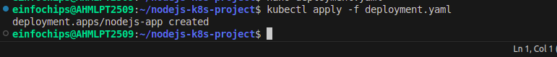

Apply the ClusterIP service:  
  
kubectl apply -f service.yaml

Apply the NodePort service:  
  
kubectl apply -f service-nodeport.yaml

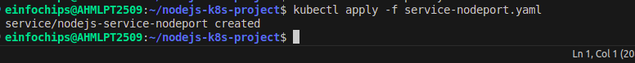

**4.4. Access the Application**

Get the Minikube IP:  
  
minikube ip

1. Access the application using the NodePort:  
     
   curl http://<minikube-ip>:30001

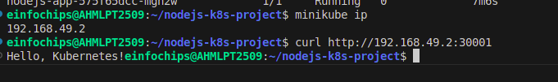

### **Making Changes to the App and Redeploying Using Kubernetes**

### **6. Making Changes to the Node.js Application**

**6.1. Create a New Branch for Changes**

Create and switch to a new branch feature/update-message:  
  
git checkout -b feature/update-message

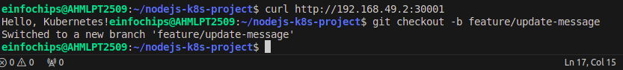

**6.2. Update the Application**

Modify index.js to change the message:  
  
const express = require('express');

const app = express();

const port = 3000;

app.get('/', (req, res) => {

res.send('Hello, Kubernetes! Updated version.');

});

app.get('/newroute', (req, res) => {

res.send('This is a new route!');

});

app.listen(port, () => {

console.log(`App running at http://localhost:${port}`);

});

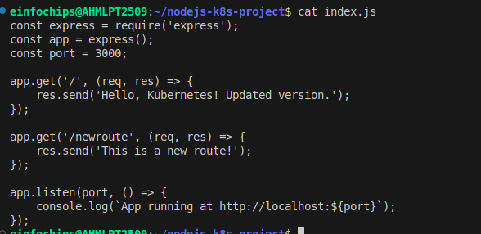

**6.3. Commit the Changes**

Add and commit the changes:  
  
git add .

git commit -m "Update main route message"

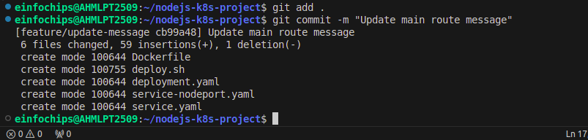

### **7. Merge the Changes and Rebuild the Docker Image**

**7.1. Merge the Feature Branch**

Switch back to the main branch:  
  
git checkout main

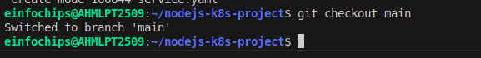

Merge the feature/update-message branch:  
  
git merge --ff-only feature/update-message

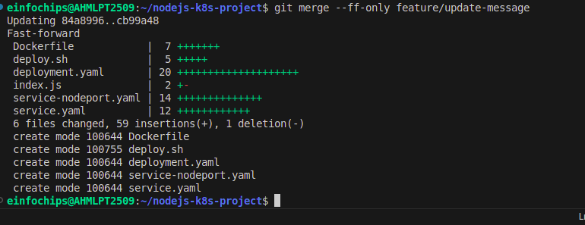

Delete the feature branch:  
  
git branch -d feature/update-message

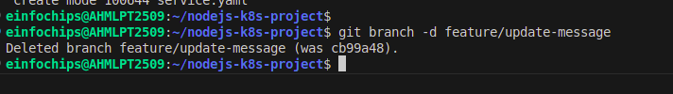

**7.2. Rebuild the Docker Image**

Rebuild the Docker image with a new tag:  
  
docker build -t nodejs-k8s-app:v2 .

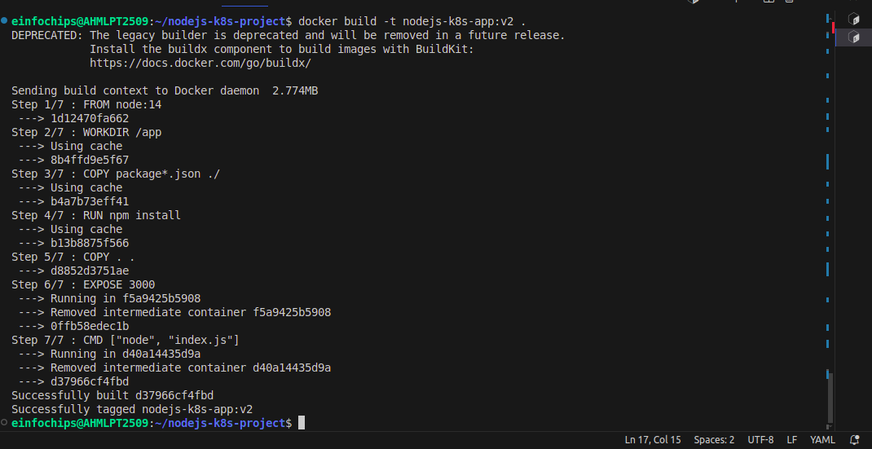

### **8. Update Kubernetes Deployment**

**8.1. Update the Deployment Manifest**

Modify deployment.yaml to use the new image version:  
  
apiVersion: apps/v1

kind: Deployment

metadata:

name: nodejs-app

spec:

replicas: 2

selector:

matchLabels:

app: nodejs-app

template:

metadata:

labels:

app: nodejs-app

spec:

containers:

- name: nodejs-app

image: nodejs-k8s-app:v2

ports:

- containerPort: 3000

**8.2. Apply the Updated Manifest**

Apply the updated deployment:  
  
kubectl apply -f deployment.yaml

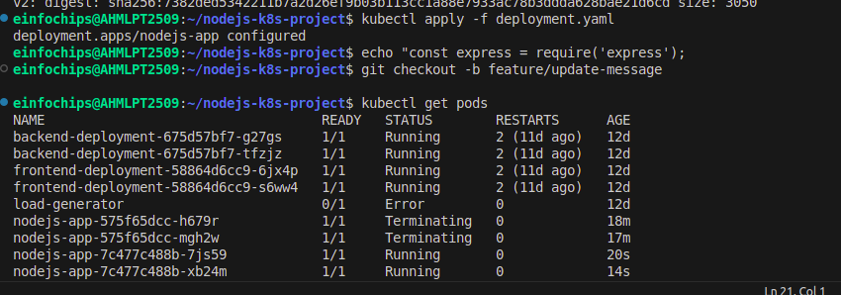

**8.3. Verify the Update**

Check the status of the deployment:  
  
kubectl rollout status deployment/nodejs-app



### **9. Access the Updated Application**

**9.1. Access Through ClusterIP Service**

Forward the port to access the ClusterIP service:  
  
kubectl port-forward service/nodejs-service 8080:80

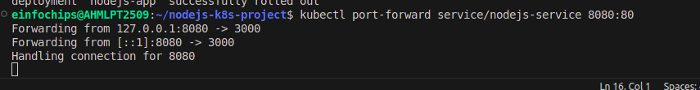

1. Open your browser and navigate to [http://localhost:8080](http://localhost:8080/) to see the updated message.

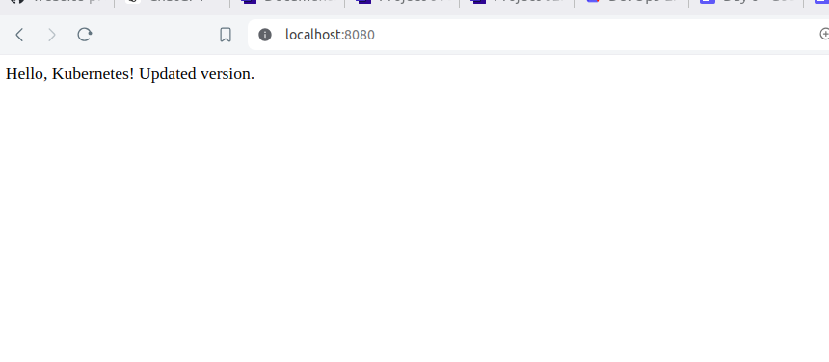

**9.2. Access Through NodePort Service**

1. Access the application using the NodePort:  
     
   curl http://<minikube-ip>:30001

